**DOCUMENTATION OF ASSIGNMENT 1**

1.Docker File:

## To create dockerfile and customized html page

1. Create a index.html under assignment_1 folder for customized page

* Create a header and one paragraph

1. Created Dockerfile under assignment1 folder

* **nginx:latest**  #Create a base image as nginx from docker hub
* **COPY** command to perform customized html page(index.html)

1. After build an image with tag name as assignment1
2. Run the image with tag name with 8080:80 port
3. Get the container id and using the container id download the default.conf file under assignment1 folder
4. Using COPY command, we can run the website in customized port

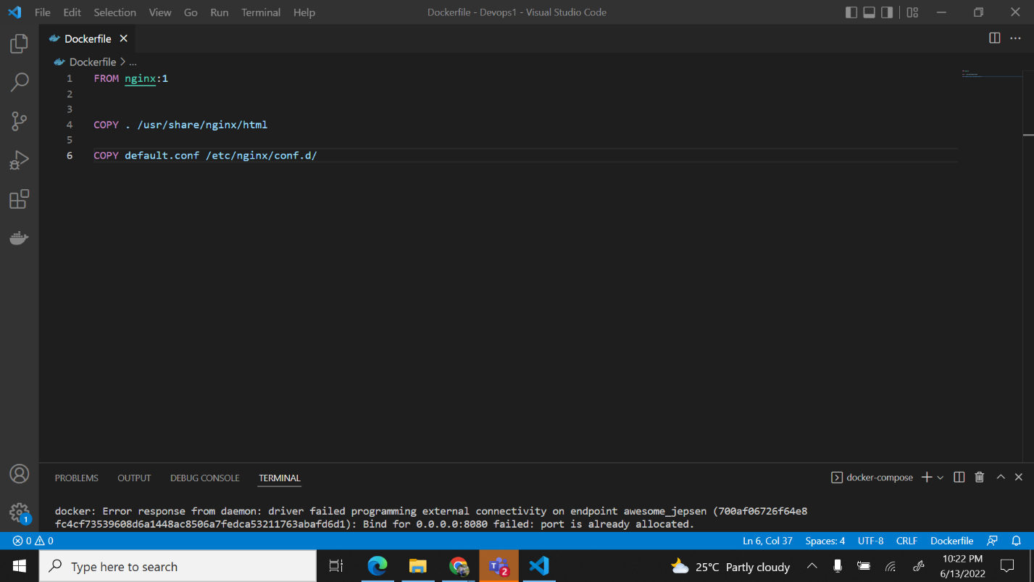

2.HTML File:

HTML file that we will be using for performing container operations.

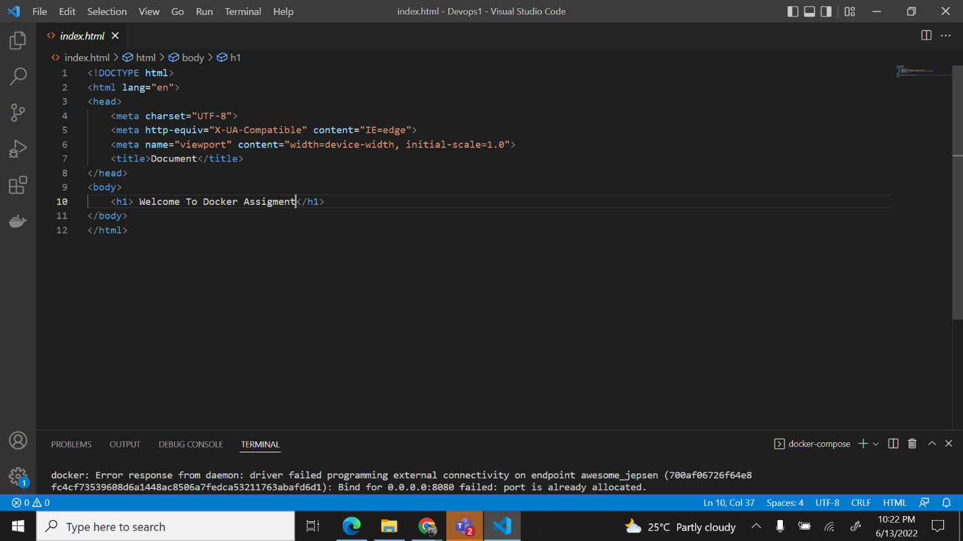

3. Dockerfile to create a web server nginx container with customized html page, and to run on port number 99 not with the default port and run it on the previously created network.

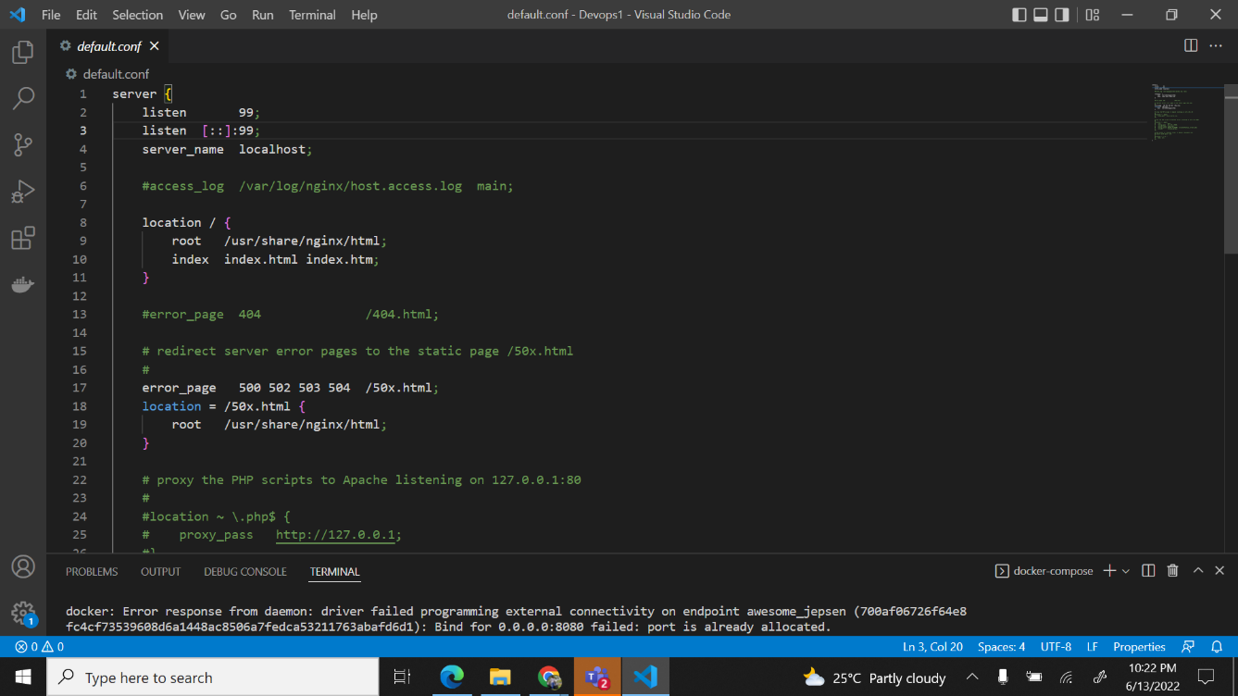

4. Locally scan the Docker file using linter and fix if any warning are there.

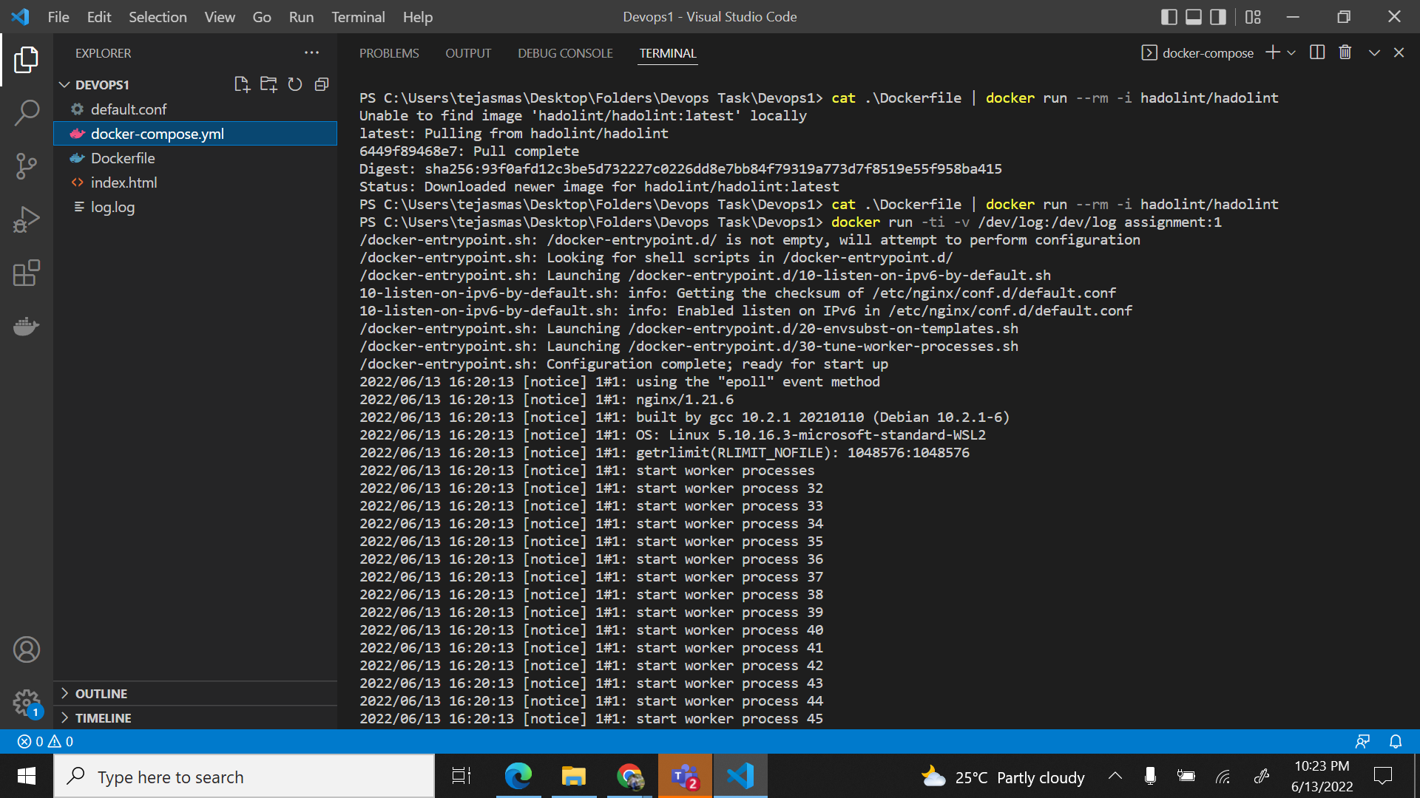

5. To store your container logs in a file

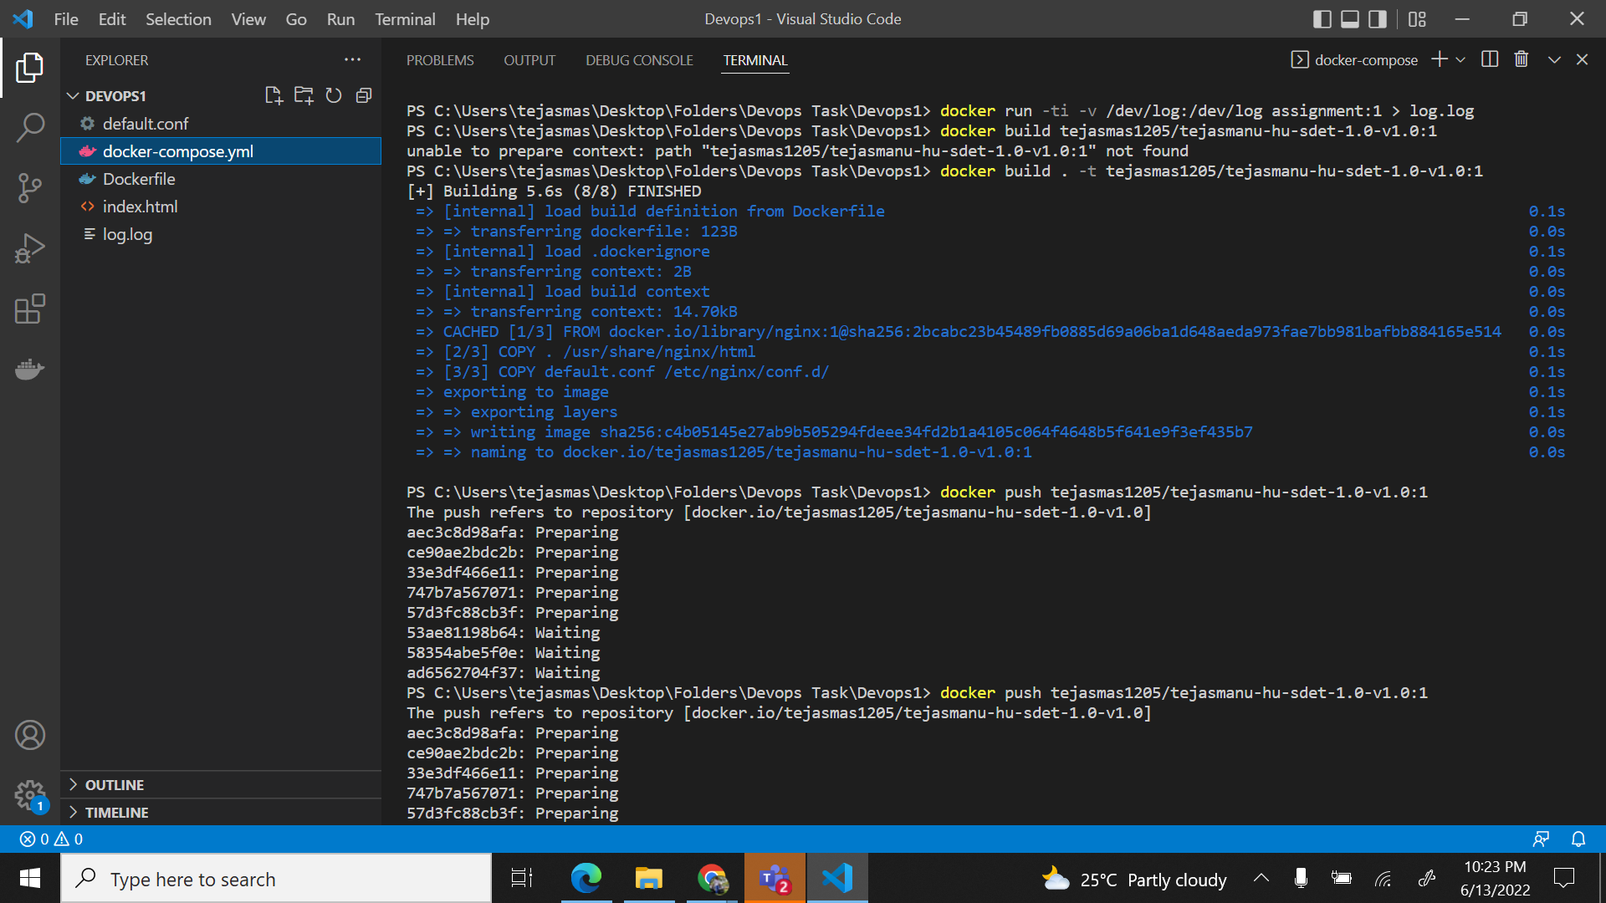

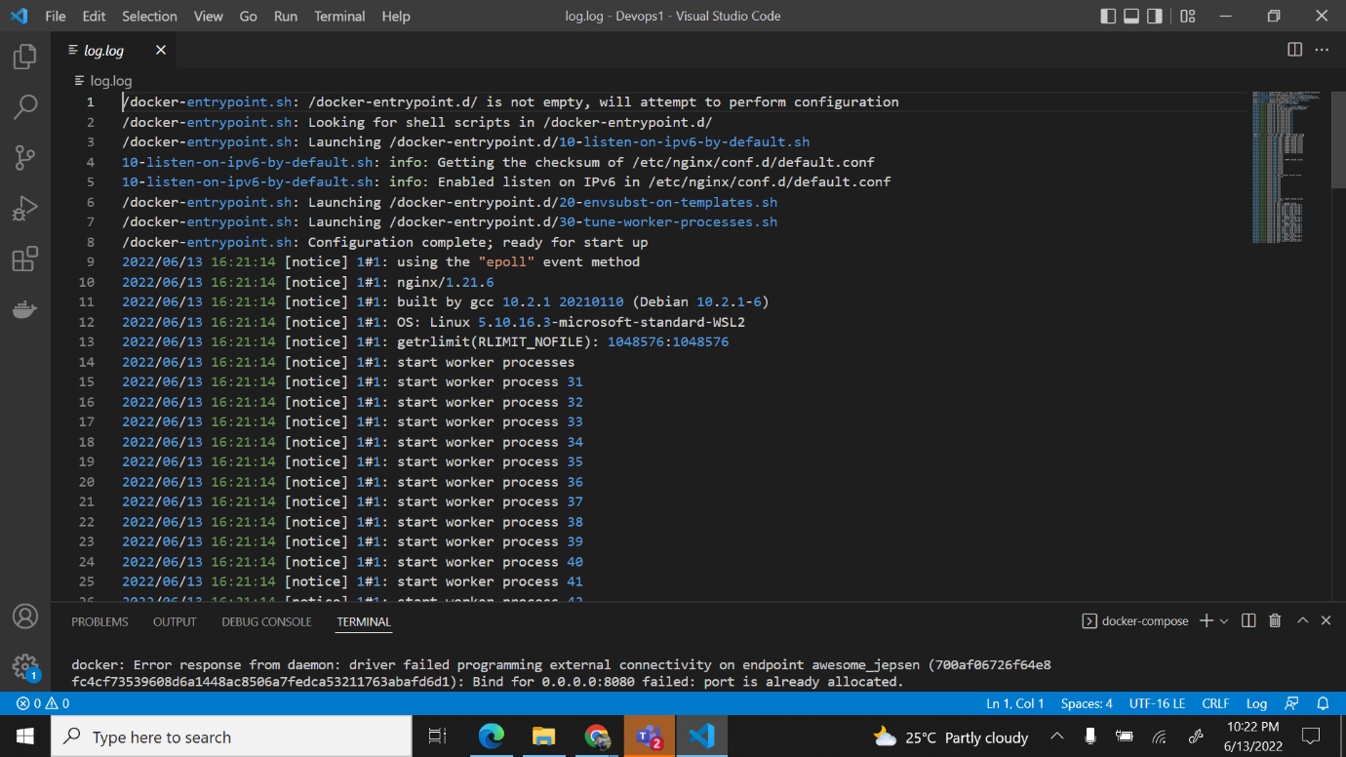

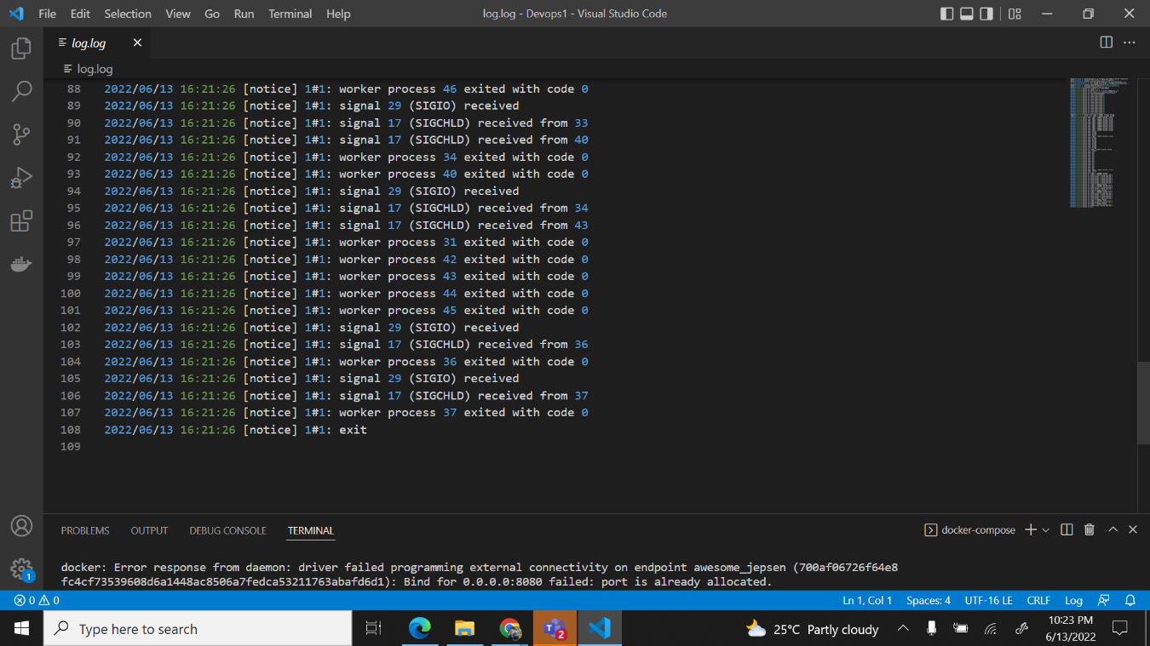

6. To Push your Docker image into the DockerHub private repository with appropriate tagging "YourName-HU-SDET 1.0-versionnumber",push the image with multiple versions.

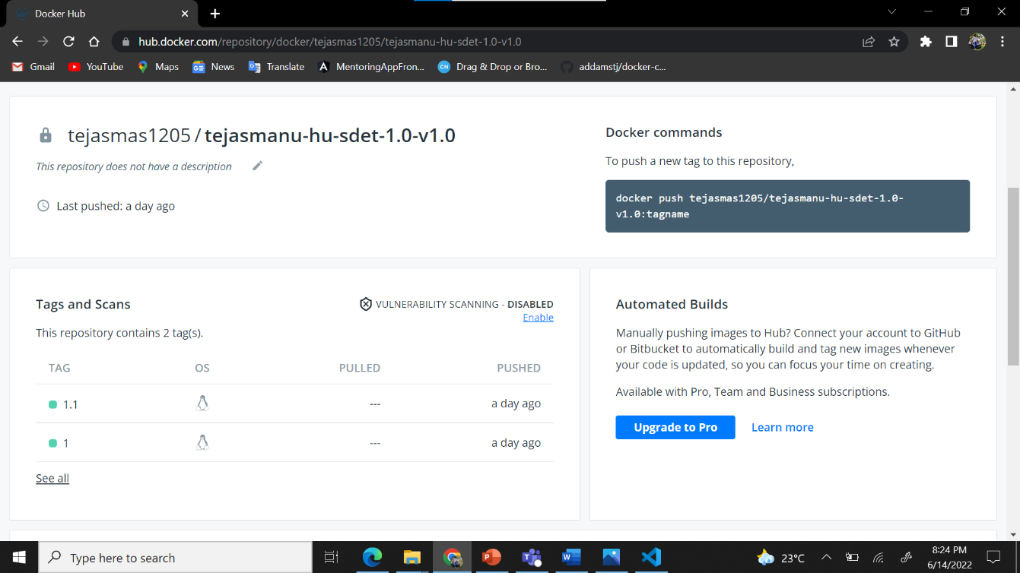

7. To Write a Docker-compose file for a web server Apache and expose with a port number 2000

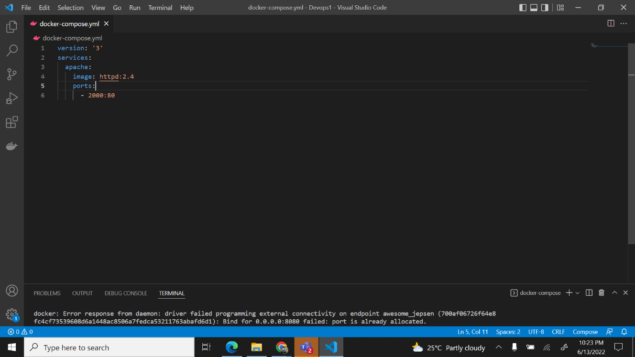

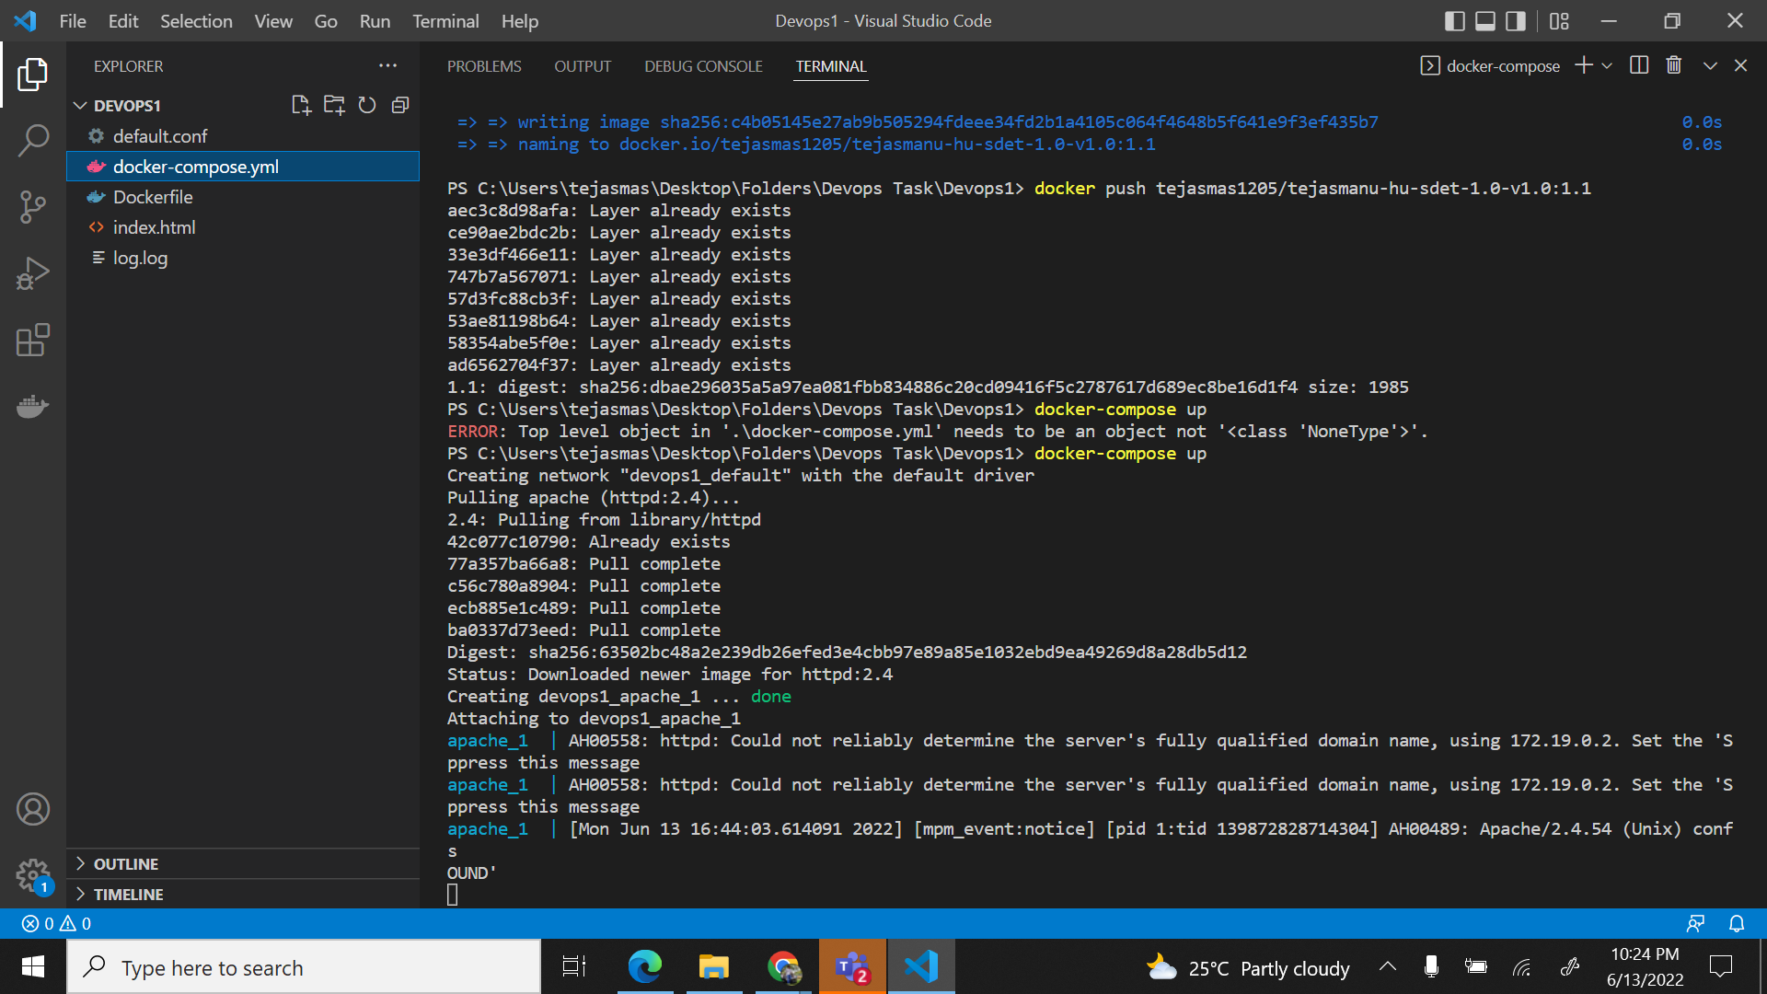

*Bindmount